

PROCESS DEFINITION

DOCUMENT

{{ CLIENT NAME }}
{{ PROCESS NAME }}

DOCUMENT VERSION HISTORY
Version | Author | Date
1.x

SIGNED OFF BY
Name | Function | Responsibility
Maria | Internet Administrator | Process Information

CONTRIBUTORS
Name | Function | Responsibility
You | Software Robot Developer | Process Automation

Current process analysis

High-level description
The process is used once a week to manually insert sales performance data for all Sales
Representatives into the intranet, and to generate a PDF report.
The company sets weekly sales goals for each sales representative. At the end of the
week, their results are exported from an existing system (not included in this process)
into an Excel spreadsheet.
Currently, the intranet administrator manually executes these operations:
- Each week a Microsoft Excel spreadsheet is exported and uploaded to the intranet webserver.
- The employee downloads the exported spreadsheet from the intranet webserver.
- The employee manually logs into the intranet website.
- The employee inserts the information for each sales representative.
- Data is collected in a table on the site, which also adds up the sales goal and the actual sales for the week.
- The employee selects the table in the browser, pastes the code into Microsoft Word, and prints the resulting document as a PDF.

Systems involved
System / Aplications | Used for | User role needed
Microsoft Excel | Collecting the sales data,  used manually by the  employee as the source of  data which is manually  copied and pasted into the  intranet. | The employee must have  access to the intranet.
Company intranet | Displaying the sales data  for all employees to see,  tallying the sales data. | The employee must have  an administrative account  for the intranet that allows  inserting data.
Microsoft Word | Formatting the sales data  taken from the website into  a PDF document.

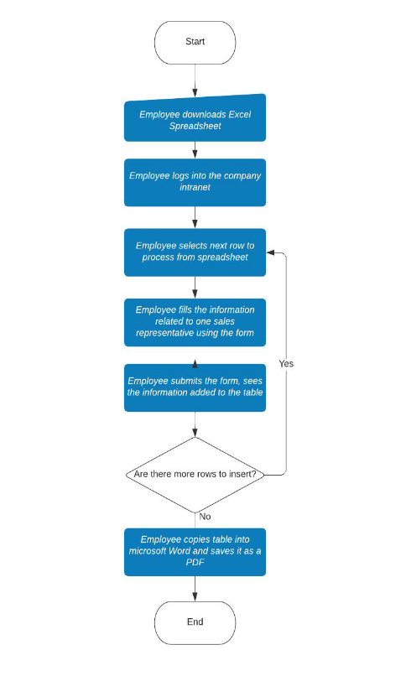
Process flow

Detailed steps
- Employee downloads the Excel file
- Employee logs into the site
- Employee inputs information of one sales representative

Possible exceptions
Exceptions are special cases and rules that can influence and even stop the smooth
running of the process.

Logic Exceptions
- Missing data - First name, last name, sales and sales target are all required: in case some of this information is missing, the sales representative’s performance will not be evaluated for the current week.

System Exceptions
- Invalid credentials - If the user provides invalid credentials, the login is not successful and the process stops.
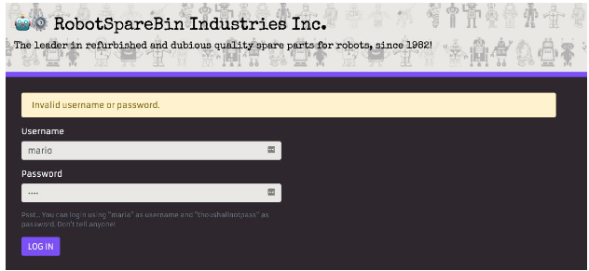
- Unexplained errors - Sometimes the intranet goes into an error state. When the error is displayed, it is apparently enough to refresh the page and resume normal operations. Affected operations seem to be logging in, logging out and deleting all existing sales data.


